Manufacturer
Case /Return No:
Date Claim is Reported:
Installation / Delivery Date:

Buyer
Case /Return No:
Contact person
Phone
E-mail
Address
City/State/Zip
Seller

Case /Return No:

Contact person
Phone
E-mail
Address
City/State/Zip

Notified Product
Article No. |  |  | Manufacturing No.
Location of installation (Name, Address, Phone)

Description of the problem (briefly). Documentation; preferably with photo / sketch
Has claim caused the resulting damage? | YES NO | Insurance company used / contacted?
If YES, description (briefly)
Terms and Conditions used?  Product placed, where? | YES NO
More information: | Sketch/Photo Text Receipt / Invoice copy

Contact the manufacturer if Case/Return number is needed.

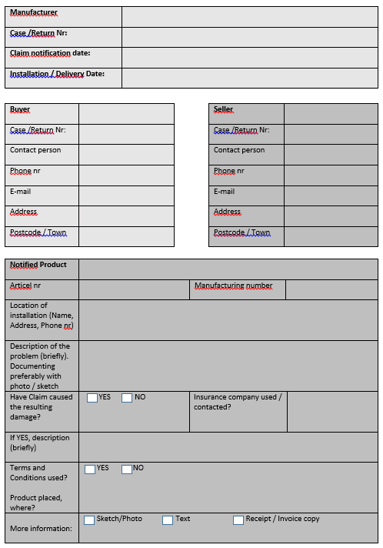
All kind of terms and conditions shall contain information about the claim type and extent
Installation / delivery date corresponds to the product's delivery to the buyer
In this form all fields must be filled in by claimant.

